# Non functional requirements:

Product requirements

1. efficiency: application should provide accurate location and clear information about each property with ease.

usability requirements: user should be able to report any difficulties they faced in the system for developers to fix.

security requirements: no user should be given owner privileges without completing their information. any type of user cannot access other type privileges

Additional requirements:

user interface: user interface should be user friendly and suitable for socializing. user interface should be simple and easy to use.

owner cannot show item with uncompleted details.

1. attachments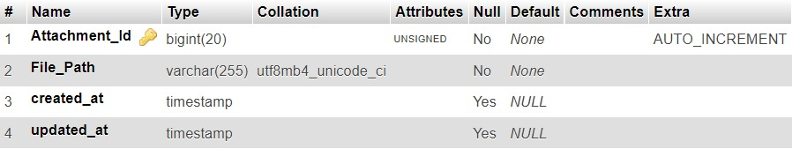
2. cities:

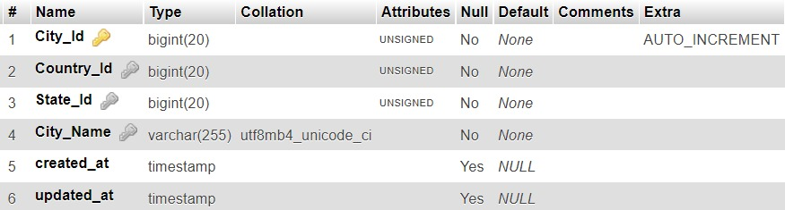

1. comments:

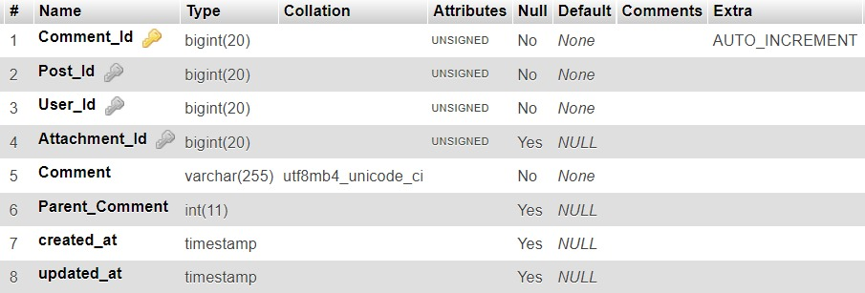

1. counties: 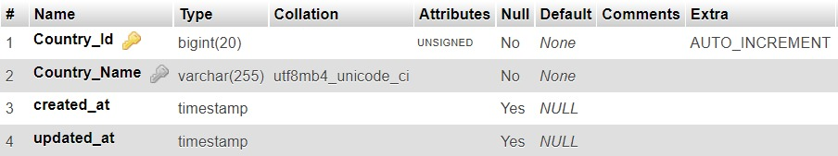
2. cover_photos:

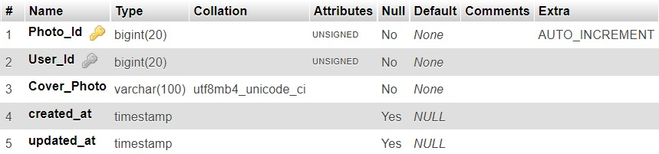

1. cover__pages:

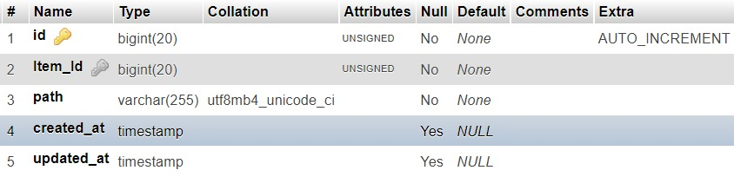

1. datatypes:

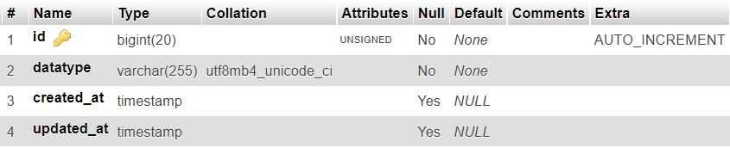

1. details: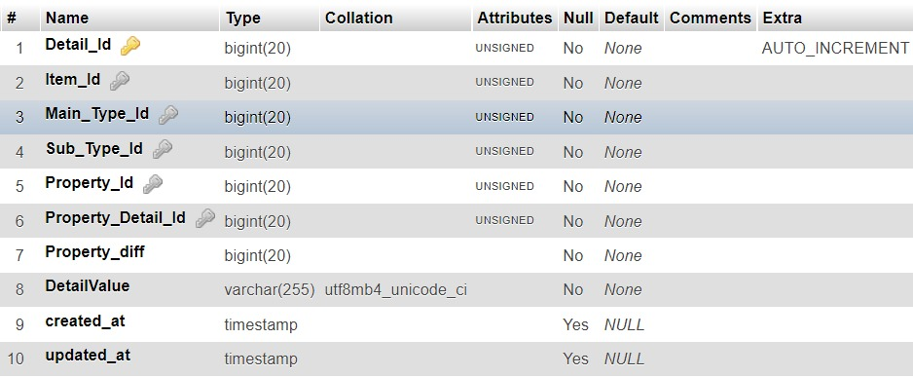
2. emails:

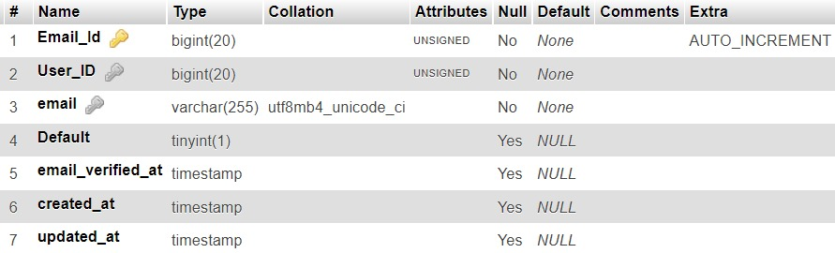

1. followeditemsbyusers:

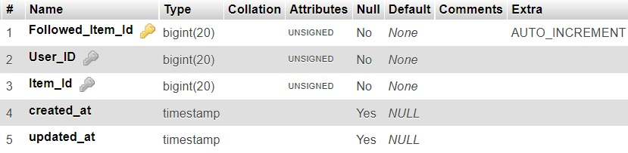

1. followedusers:

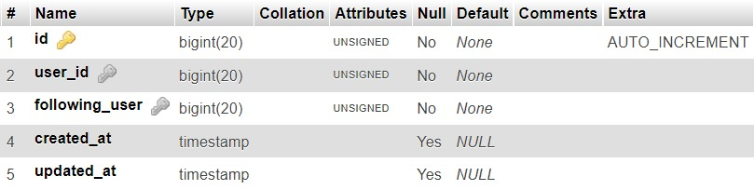

1. items: 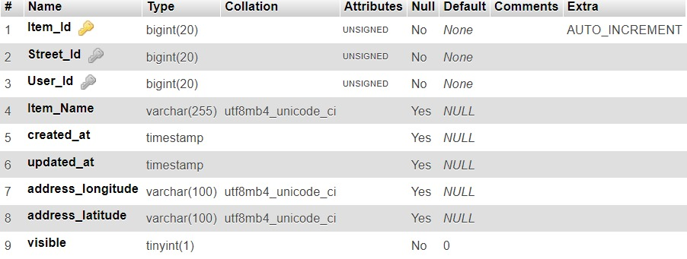
2. main__types:

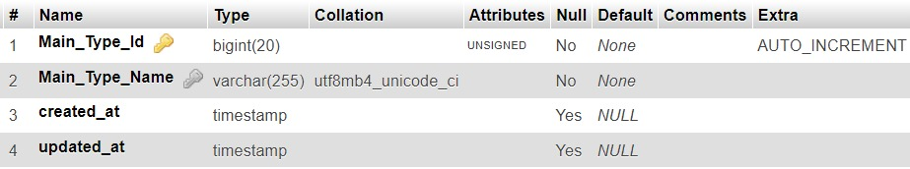

1. notifications:

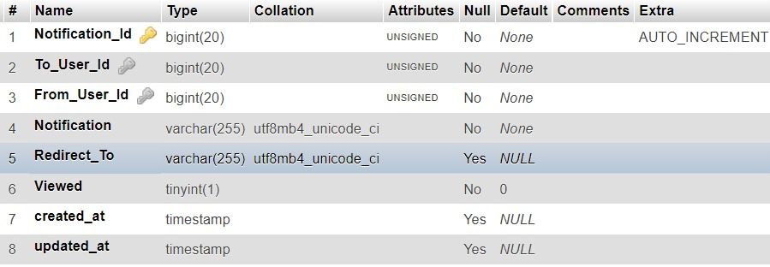

1. operation__detail_name:

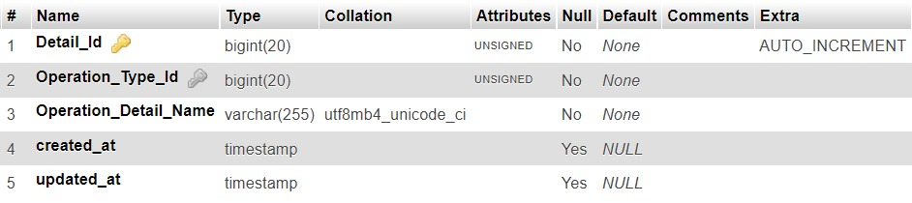

1. operation__types:

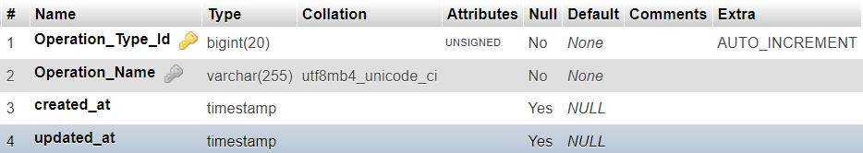

1. operation___detail__values: 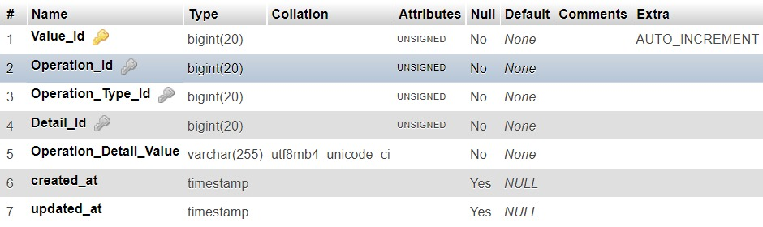
2. operations:

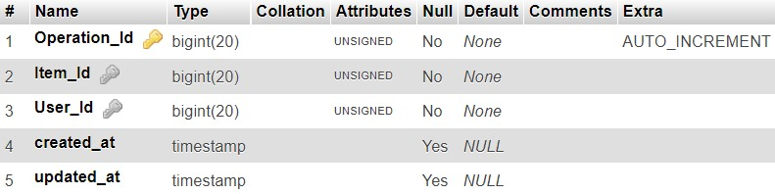

1. payments:

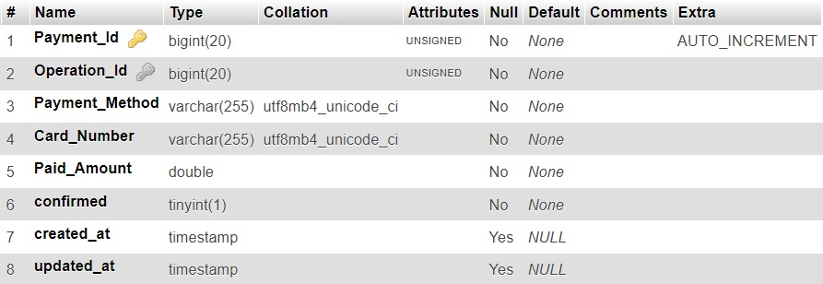

1. phone__numbers:

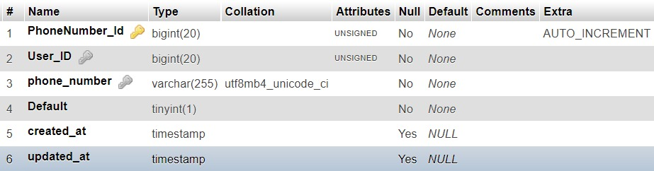

1. posts:

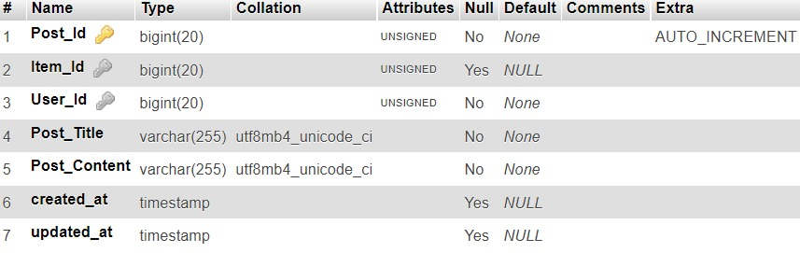

1. post_attachments: 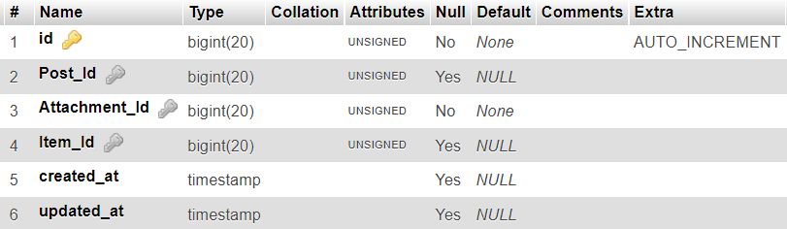
2. profile_photos: 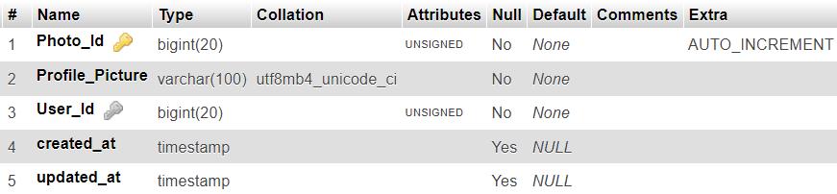
3. property__details: 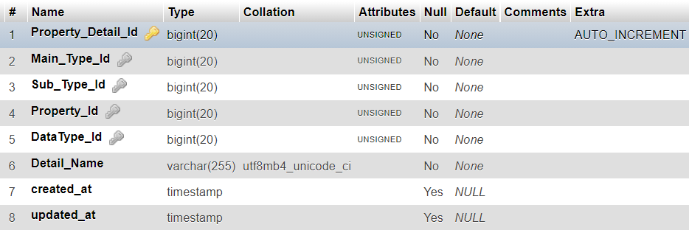
4. regions: 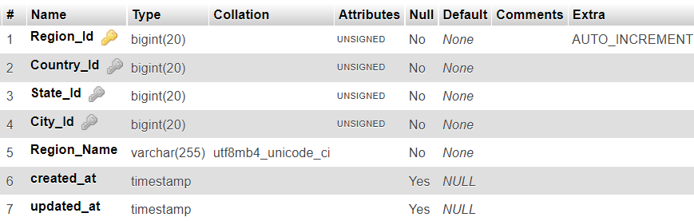
5. reviews: 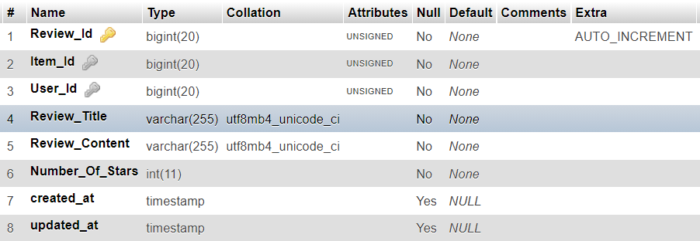
6. review_attacments: 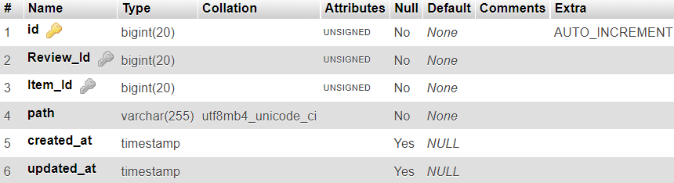
7. reviewcomments:

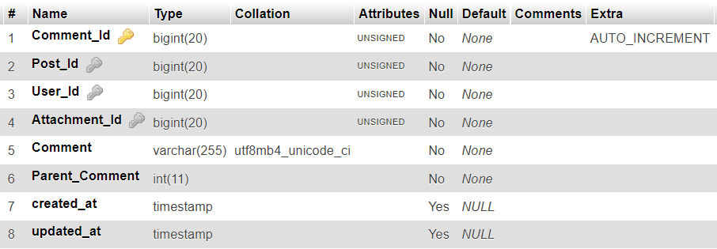

1. states: 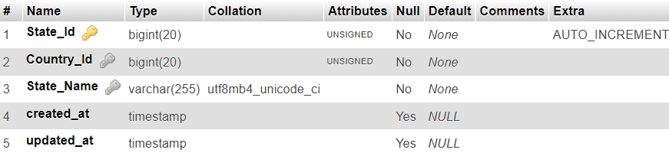
2. schedules: 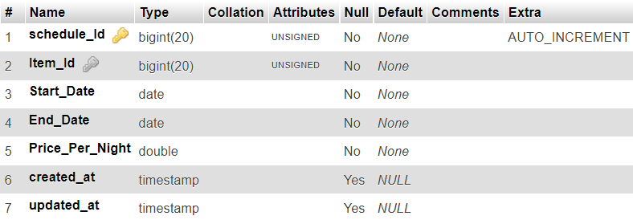
3. streets: 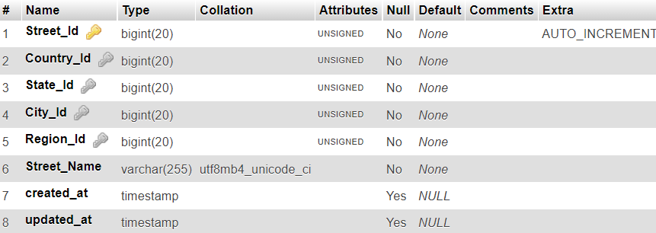
4. syb__types: 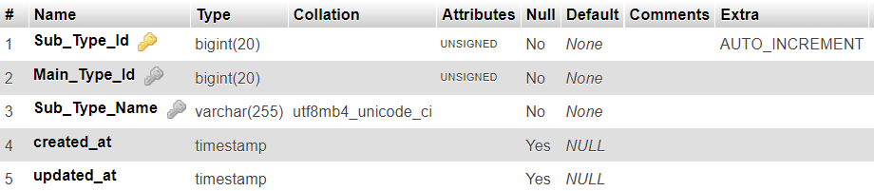
5. syb__type__properties: 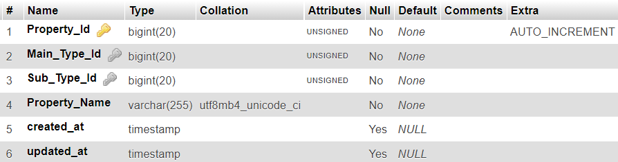
6. type__of__users: 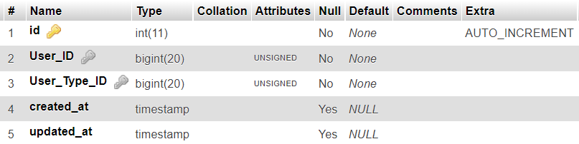
7. users: 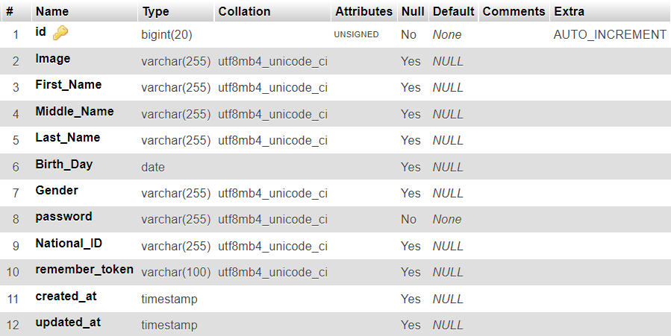
8. user__types: 